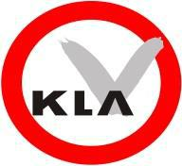
KLAGSVERBAND ZUR DURCHSETZUNG DER RECHTE VON DISKRIMINIERUNGSOPFER
Schönbrunner Straße 119/13, Eingang: Am Hundsturm 7, 1050 Wien
W: www.klagsverband.at
M: info@klagsverband.at
T: +43-1-961 05 85-13

Annual Report 2015

Imprint
Litigation Association of NGOs Against Discrimination
(Klagsverband zur Durchsetzung der Rechte von Diskriminierungsopfern)
Address: see above

Bank Details
Bank Austria
IBAN: AT34 12000507 8666 9801
BIC: BKAUATWW

Translation: Alexandra Mitterer

The Litigation Association is financially supported by:

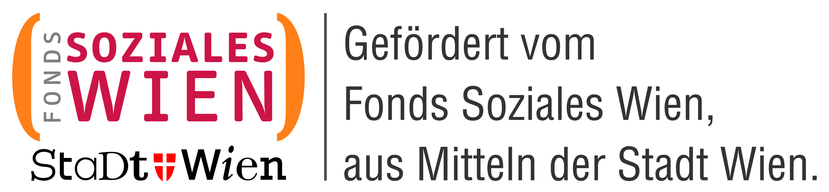
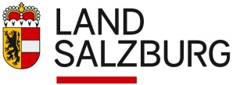

CONTENTS

2015 in numbers 3
Klagsverband and its members 4
Focus of the year: UN individual complaints 5
Judicial process 6
Legal policy 8
Workshops and training 9
Public relations 9
Documentation of legislature 10
Networking 10
For 2016… 10

2015 IN NUMBERS

2 new lawsuits were filed by Klagsverband, the first one of which was concerned with racist discrimination in the allocation of homes; in the second case, public liability claims (Amtshaftungsklage) have been brought against the City of Vienna because of an observation tower which is not accessible.

2 court decisions reached us in 2015: A female student who had been discriminated against during an employment application process was granted 2,500 Euro in damages. The second decision relates to a lawsuit against Linz Linien, the public transit system of the city of Linz, in response to the lack of accessibility in new tram stations. Even though the lawsuit was previously unsuccessful in two courts, an individual complaint to the UN eventually resulted in the finding that the Convention on the Rights of Persons with Disabilities of the UN had been violated.

3 new member organizations joined Klagsverband: knack:punkt Salzburg, Fibel, and Aktive Arbeitslose Österreich.

4 opinions were written by us, including a shadow report for the Universal Periodic Review, the universal human rights review of the UN.

7 press releases were issued.

19 workshops were held by the Klagsverband team. In Vienna alone, eight workshops made up the new Klagsverband traning series “My rights make me strong!”.

23 Klagsverband alerts were sent out to inform readers quickly about interesting news on www.klagsverband.at.

59 new articles were published on our website.

64 inquiries on legal issues have been revised by our lawyer. In all of these instances, she first has to clarify whether the problem described in these inquiries fall within the scope of anti-discrimination and equal opportunity laws.

KLAGSVERBAND AND ITS MEMBERS

Klagsverband is an umbrella organization with currently 42 member organizations. The association was founded in 2004 by the organizations BIZEPS – Independent Living Center Vienna, ZARA – Civil Courage and Anti-Racism Work, and HOSI – Homosexual Initiative Vienna.

Purpose
-model procedures according to Austrian equality law
-documentation of legislature
-legal education
-legal policy

Financing
-public funds: Federal Ministry of Labour, Social Affairs and Consumer Protection, Federal Ministry of Education and Women's Affairs, the State of Salzburg, Fonds Soziales Wien
-membership dues
-donations
-project-related funding

The advisory activities of Klagsverband’s member organizations cover all grounds for discrimination included in Austria’s equal opportunity law.

A list of all members can be found on our website: http://klagsverband.at/ueber-uns/mitglieder

NGOs and non-profits that work to combat discrimination may become full members of Klagsverband.

The Tyrol Service Center for Equal Treatment and Anti-discrimination assists Klagsverband as a supporting member.

Klagsverband members receive the following services:
- Legal counselling
- Support during arbitration proceedings and in appeals before commissions
- Legal representation in court, when legally possible
- Counsellor training
- Networking and legal expertise for lobbying
- Opinions on legislation

FOCUS OF THE YEAR: UN INDIVIDUAL COMPLAINTS

In 2015, Klagsverband supported a blind client from Linz on a lawsuit: Linz Linien, the public transit system of the city of Linz, had extended a tram line and failed to equip the new stations with voice output technology. However, two courts were not able to determine that discrimination had taken place. Since Klagsverband had exhausted all legal instances at the national level, an individual complaint within the framework of the Convention on the Rights of Persons with Disabilities of the UN was the last legal means remaining.

In September 2015, a response to the complaint came from Geneva to partially correct the opinion of the Austrian courts: The Committee on the Rights of Persons with Disabilities determines that Austria has violated its commitment to create non-discrimination (CRPD art. 5 par. 2) and accessibility (CRPD art. 9 par. 1 and 2). It has been recommended that the Austrian government should establish legal minimum standards for accessibility in public transit for blind and visually impaired people, and ensure that these standards are enforceable. The Austrian ministries now have time to react to these UN recommendations until March 2016.

Series of online articles: All international conventions provide the option of individual complaints. However, this legal instrument is hardly utilized. In an eight-part series of online articles published from July to October 2015, we informed our readers about the advantages and disadvantages of individual complaints.

Topical Focus Individual Complaints at the Klagsverband’s closed meeting: We also informed our members about our topical focus during our annual closed meeting and motivated them to increasingly consider this still largely unknown legal instrument in the future.

JUDICIAL PROCESS

*The number of court cases given in this graphic refers to the number of new cases in the respective year.

New lawsuits

“This apartment is taken”: Our plaintiff was interested in a vacant apartment and called the real-estate agency. She was told that the apartment had already been taken. However, the plaintiff had had negative experiences before, and so she asked her colleague, who speaks accent-free German, to call the real-estate office as well. When her colleague did so five minutes later, the apartment was still on the market. Klagsverband filed a lawsuit on the grounds of discrimination in access to goods and services. If this proceeding ends with a verdict, it will be the first decision under the Equal Treatment Act (GIBG) which addresses racist discrimination in the allocation of homes.

Observation tower in Vienna not accessible: Next to the ice rink in front of the Wiener Rathaus, the city hall of Vienna, an observation tower was built in 2015. While the tower did have a ramp and a lift, wheelchair users were still not able to access it. For our plaintiff, we filed public liability claims (Amtshaftungsklage) against the City of Vienna, which approved the construction of the tower despite its insufficient accessibility.

Completed proceedings

No job for a Muslim woman with headscarf: A young student received 2,500 Euro in damages after she had been discriminated against during an employment application process. The young woman wears a headscarf for religious reasons and applied for a part-time service position in 2011. In her application picture, it was clearly visible that she was wearing a headscarf. Shortly after she had sent the application, she was called by a member of staff of the café. She was told that the position was still available and asked whether she was still interested. When the young woman said yes, the staff member told her: “During your working hours, you’d have to take off your headscarf.” The woman did not want to do so. For this reason, she was not further considered for the position. Klagsverband filed a lawsuit on behalf of the young woman. The accused company paid the sum before the proceedings were opened.

New tram stations without voice output technology: These proceedings have come to a happy end thanks to an individual complaint to the Committee on the Rights of Persons with Disabilities of the UN. However, before the filing of this complaint, two Austrian courts had not been able to determine that discrimination had taken place. A tram line in Linz had been extended and the new stations – unlike the already existing stations – were not equipped with voice output technology. Our plaintiff filed a lawsuit for discrimination under the Austrian Federal Act on the Equalization of Persons with Disabilities (BGStG), but as mentioned earlier, this lawsuit was not successful. For this reason, we sent an individual complaint to the UN Committee on the Rights of Persons with Disabilities in March 2015. The committee responded in September and determined that the UN Convention on the Rights of Persons with Disabilities had been violated. The Austrian government received a number of recommendations for the improvement of accessibility in public transit and especially in communication technologies. We expect an answer of the ministries responsible in March.

Proceedings pending from the previous years

Racism at a dance club entrance: Sadly, racism-motivated denial of entry to clubs, bars, discos and other venues is part of everyday life for many people with migration background. Klagsverband now filed a lawsuit for a group of eight people who encountered problems when trying to enter a club in Vienna. Three young men were denied entrance by the bouncer, and the remaining three friends and two young women who had already been waiting in the club were forced to leave too after a discussion with the bouncer. The Equal Treatment Act (GIBG) also includes protection for people who are associated with a discriminated person.

A case for Klagsverband

For each inquiry passed on to us by our member organizations, it must first be determined whether the case is suitable for a lawsuit. During a personal consultation, Klagsverband determines if going to court makes sense. Klagsverband primarily pursues model case proceedings. Prior to legal proceedings, a series of questions must be answered: Which type of law is being dealt with? How high are the projected litigation costs? What does the aggrieved party expect from a trial? Above and beyond the particular case, will the verdict also be suitable for raising awareness of Klagsverband and its member organizations? Such questions are examined by the Klagsverband lawyer, who then makes a recommendation on whether it is worthwhile to go to court. An internal board has the final decision.

LEGAL POLICY

Laws can combat discrimination, but they can also cause it. Klagsverband participates in political processes actively through written opinions and tries to influence legislation in the interest of equality and anti-discrimination policy. The special strength of Klagsverband in this area is to find discrimination-related aspects even in laws which are not mainly an instance of equal treatment legislation. In the past years we also increasingly contributed to the development of human rights standards through shadow reports regarding international conventions and monitoring processes.

In 2015, we wrote following opinions:
-criminal law act (Strafrechtsänderungsgesetz)
-amendment to Salzburg’s Equal Treatment Act
-amendment to the General Law on Social Security (Allgemeines Sozialversicherungsgesetz)

We also wrote a shadow report for the Universal Periodic Review, the universal human rights review of the UN.

WORKSHOPS AND TRAINING

“My rights make me strong” – Series of workshops on anti-discrimination law
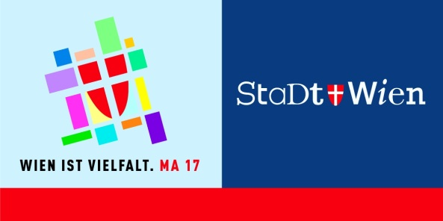
Through a series of workshops consisting of a basic workshop and an in-depth workshop, we were able to offer a comprehensive introduction into anti-discrimination law for a variety of target groups for the first time. In Vienna, we organized four basic workshops with in-depth follow-ups between May and November 2015. These workshops were funded by the City of Vienna, MA 17.

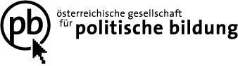
This series of workshops is also taking place in Upper Austria. In 2015, a basis workshop was held. Two more basic workshops and two in-depth workshops are planned for 2016. Our co-operation partner in Upper Austria is the organization maiz, the series of workshops is supported by the Austrian Society for Political Education (Österreichische Gesellschaft für politische Bildung).

Also part of our range of training seminars are workshops for our member organizations as well as customized offers for interested associations, organizations or individuals.

PUBLIC RELATIONS

Media Outreach: Part of the media/press outreach work of Klagsverband is the distribution of rulings in Klagsverband’s legal proceedings as well as opinions and comments to issues of legal policy.
Press releases 2015: http://www.klagsverband.at/service/presse

Website as communication platform: In the news section of www.klagsverband.at, a new article about legislature, legal policy or equal treatment topics is posted once a week on average.

Klagsverband-Alert: Klagsverband-Alert is a special service with which our users are informed about articles which might be interesting for an especially large number of readers.

Inquiries: Part of PR includes answering the many inquiries concerning issues of equal rights, anti-discrimination, and diversity. Klagsverband gladly offers its experience and expertise to students, researchers, employees of public institutions, political parties, and interested citizens. The dissemination of experience in judicial process for national and EU studies is especially important for the sustainability of verdicts and the political debates on improving the legal framework.

DOCUMENTATION OF LEGISLATURE

The services of Klagsverband include documenting and commentating on national and international legislature.

NETWORKING

Klagsverband lives from the vitality of its member organizations and from contacts to other organizations and NGOs that work towards abolishing discrimination. There is an ongoing exchange with the National Equality Body, the National Disability Body, state anti-discrimination bureaus, federal ministries, and other social partners. Since 2013, Klagsverband has also been a member of the Monitoring Committee of Lower Austria.
Within a European context, membership in the Fundamental Rights Platform of the European Fundamental Rights Agency (FRA) is of special importance. Since it has a central counseling function regarding human rights and anti-discrimination for the European Commission, experiences of Klagsverband can be relayed to relevant decision-making bodies.

FOR 2016…

…we plan an accessibility offensive for our website, new print products and a series of discussions about specific aspects of anti-discrimination and equal treatment work.

